.

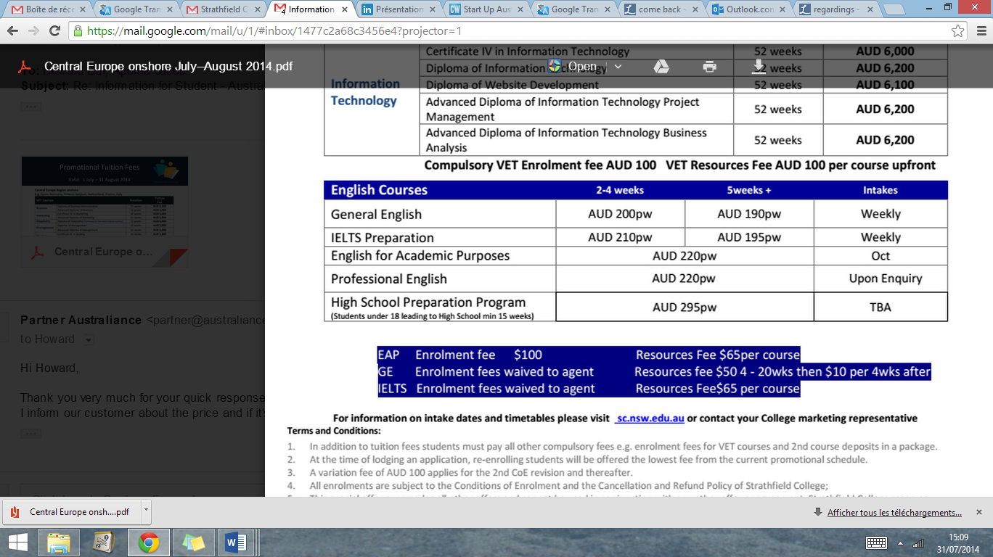

AUSTRALIANCE

Digital Marketing & Business Development

**Australiance,** part of **PmC Group**, is a growing business started in  
Sydney 4 years ago. This branch owns and operates [**www.**](http://www.Australiance.com)**a**[**ustraliance.com**](http://www.Australiance.com)  
and [**www.**](http://www.Australiance.fr)**a**[**ustraliance.fr**](http://www.Australiance.fr), whose primary purpose is to assist international professionals, students and small businesses to settle in Australia.

After 4 years of activity and experience Australiance wants to grow and pass to another stage, the main reason of this internship offer. A great experience if you want to come back and start your career in Australia!

**Duration**: 6 months  
**Location**: Sydney  
**Salary**: 250$/month + good compensation on results  
**Position**: **Digital** **Marketing Analyst & Business developer**.

6-months Internship   
**Sydney**

Available from December 2014

English: professional Spanish/Italian: a strength

CRM, Wordpress (HTML + CSS), MailChimp

Knowledge in Photoshop.

Digital Marketing required

Project management a must

Entrepreneurial spirit.  
Fast learner, highly motivated.

Strong communication skills. Desire to take initiative and rise to the challenges.

* Search, Analyze and Select to contract new partnerships
* Become a ninja for web marketing campaigns
* Manage and promote Australiance’s events
* Build, develop and grow new arms of business to increase profits by 30% for Australiance-coaching solution

As Business Developer you will create new business opportunities through new partnerships based on Australiance’s new business model.

As WebMarketing Ninja you will provide analysis, forecasting and reporting that inform and improve the effectiveness of the planning, execution and optimization of marketing strategy. You will also be in charge of managing leads through online and offline channels to increase conversion rate.

Experience

Requirements and  
key Skills

IT

Behaviour

Language

More information:

[hr@australiance.com](mailto:hr@australiance.com) [www.australiance.com/recruitment](http://www.australiance.com/recruitment)

**Key missions:**

Interested? Send us your resume at [hr@australiance.com](mailto:hr@australiance.com)